KENYA KEYS


BOARD OF DIRECTORS MANUAL
A guide to
Board of Directors Roles and Responsibilities
KENYA KEYS

BOARD OF DIRECTORS MANUAL

A guide to

Board of Directors Roles and Responsibilities

Compiled by:
J. Mwengea
(Co-founder and Executive Director)
January 2025

CONTENTS

CONTENTS 2
1.0 KENYA KEYS VISION AND MISSION 3
2.0 Introduction 4
3.0 Appointment of Board of Directors 4
4.0 Current Board of Directors Profiles 6
5.0 Roles of Board of Directors 16
6.0 Board Sub-Committees 17
7.0 APPENDIX I: Appointment Letter 20

KENYA KEYS VISION AND MISSION

Vision
To alleviate poverty, offer mentorship and promote access to education.
Mission
To provide scholarships, to needy and bright students to access education and offer mentorship and leadership development.
Identity Statement
An entity of scholars committed to community transformation through education.
Philosophy Statement
Transforming lives, Enhancing livelihoods

Current Board of Directors Profiles

Eunice Ndunge Kioko
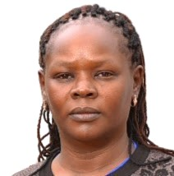
Eunice Ndunge Kioko is an accomplished educator and administrator with over 15 years of experience in teaching, academic leadership, and community development. She currently serves as the Chairperson of the Board of Directors for Kenya Keys, a non-governmental organization dedicated to transforming lives through educational sponsorship and support for underserved students in the Taru region of Kenya.
Ms. Kioko holds a Master of Business Administration (Strategic Management) from Kenyatta University. She holds a Bachelor of Education (Arts) in Business Studies and Economics from the University of Nairobi and is a Certified Public Accountant (CPA-K). Her academic background is complemented by extensive professional experience in both teaching and institutional leadership.
She serves as a part-time lecturer at Taita-Taveta University and as Head of the Business Department at Taita Taveta National Polytechnic, where she has played a key role in curriculum implementation, departmental planning, and student mentorship. Her responsibilities have included academic coordination, staff oversight, examination administration, and quality assurance.
In her role as Chairperson of Kenya Keys, Ms. Kioko provides strategic leadership and governance oversight, drawing upon her deep understanding of education systems and financial management. She is passionate about using education as a tool for empowerment and is particularly committed to advancing opportunities for youth in marginalized communities. Her leadership continues to guide the organization toward sustainable impact and growth.

Elias Ngao Tsuma
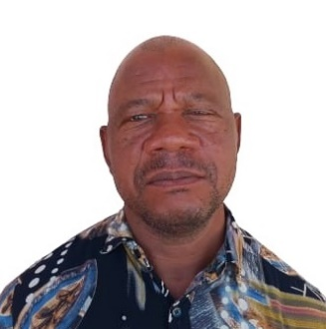
Elias Tsuma is member serving in the Board of Directors Kenya Keys in charge of community outreach and infrastructure oversight docket.
He holds a Diploma in Special Need Education (SNE) from Shanzu Teachers Training College. He holds a Certificate in Teacher Education (PTE) from Shanzu Teachers Training College.

He is a compassionate and dedicated Headteacher of Comprehensive Government Primary School comprised of elementary school and Junior Secondary School. Employed by Teachers Service Commission, he has a long experience in matters of Education: teaching pedagogy, Institution Finance Management, Student Mentorship and Collaborative Community Working experience with parents and donors. He was a Board of Director of the previous Kenya Keys Board of Directors and currently re-appointed as Board of Director member.
Mr. Elias is currently a Headteacher at Magale Primary School. He has served as a Headteacher at Mwaruphesa Primary School, Headteacher Kituu Primary School and Deputy Headteacher at Bahakwenu Primary School. He began his professional teacher career at Egu Primary School as a classroom teacher instructor.
He brings to the Kenya Keys Board: a wealth of experience in school and community management practices, construction experiences in school infrastructure, student mentorship and financial reporting skills obtained from the government practices.

Joseph M. Mwengea

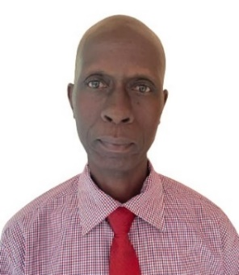
Mr. Joseph Mwengea is the Co-founder and Executive Director of Kenya Keys, a non-governmental organisation offering scholarship to needy and bright students in Kwale County and other rural parts of Kenya.
He holds several accolades among them a Masters of Business Administration (Project Management) from Kenyatta University. He holds a Bachelor of Education (Special Education) Second-Class upper Division from Kenyatta University. He also has a Diploma in Education Management (DEM) from Kenya Education Management Institute (KEMI), Diploma in Special Needs from Kenya Institute of Special Education (KISE). Certificate in School Development Planning from Ministry of Education and Centre for British Teachers. He also holds Certificate in Teacher Education (PTE) from Machakos Teachers Training College.
Joseph Mwengea started his career as a teacher and taught for over Thirty years teaching experience from the public sector.
He served in the public service, Teacher Service Commission in the Ministry of Education working as a Headteacher at Magale Primary School, Headteacher CAFGEM BARETTO Primary School and Headteacher Bahakwenu Primary School. He previously served as Deputy Headteacher at Bahakwenu Primary School and Teacher at Chengoni Primary School.
He is a contemporary leader, passionate educationist and mentor inspiring young generation in need of education and social economic transformation in his philosophy of transforming lives, enhancing livelihoods. Since the founding of Kenya Keys NGO, he has been able to offer opportunities to many students to get equal chance to access education and to be the future leaders of tomorrow realizing their potential and dreams.
He brings on board a wealth of knowledge and experience in School Administration, Management and community grassroot mobilization initiatives.

Dr. Mike Mutua
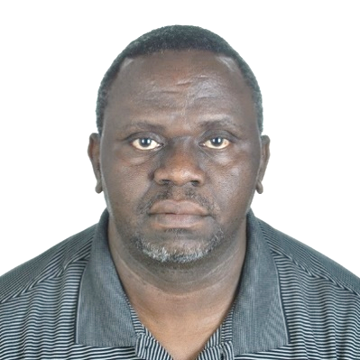
Rev. Dr. Mike Mutua is a serving Board of Director Kenya Keys in charge of Governance and Administration oversight.
He holds a Doctor of Ministry in Organizational Leadership (Leadership Integrity) from Asbury Theological Seminary, KY USA. He holds a Masters of Theology in Biblical Interpretation from University of Aberdeen, UK and a Masters of Arts in Church History from Africa International University [Nairobi Evangelical Graduate Sch. of Theology]. Dr. Mike Mutua also Holds a Bachelor of Theology from Scott Christian University (Scott Theological College) and a holder of Kenya Advanced Certificate of Education (A-Level) from Mumbuni High School and Kenya Certificate of Education (Division one) from Maseno National School.
Currently a serving National Bishop of LifePoint Ministries Kenya. University Adjunct Lecturer at Daystar University and Scott Christian University. Before he was a College Principal at Pwani International Christian College in Mombasa. He served as Executive Pastor, member of the senior pastoral team at Crossroads Fellowship Ministries, Nyali Mombasa. He is currently a Founder and Lead Communicator at The Ark Consult. Attending to leadership Coaching, Leadership Development Training, Motivational/Inspirational Lectures and Talks.
Dr. Mike M. Mutua is a very passionate Christian leader, a well-trained and an experienced University Adjunct Lecturer (Daystar University), Leadership Coach & trainer, Bishop, Mentor, and a perpetual learner. He is committed to leadership integrity, excellence, and hard work. He is self-driven but thrives in collaborating, networking and teamworking. Mike serves to honor God by transforming the lives of individuals and communities to achieve their full potential and fulfilment as they exploit their God-given skills and resources.
He brings a strong leadership in organizational governance, administration oversight with high levels of intergrity and spirit of excellence. He posses great wealth of knowledge in running charity oganization.

Dr. Emmanuel Mwengea Mwengi
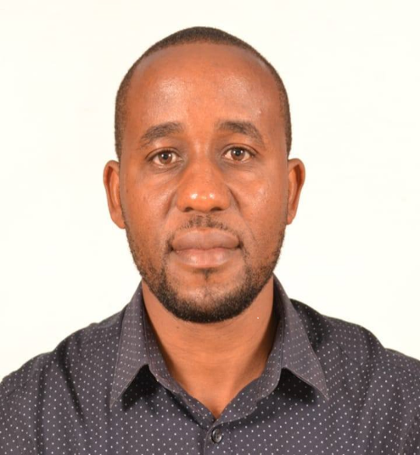
Dr. Emmanuel Mwengea Mwengi is serving in the Board of Directors Kenya Keys in charge of Planning and Development.
Dr. Emmanuel Mwengi holds Masters Degree in Clinical Pharmacy (Internal Medicine/Oncology) and a Bachelor of Pharmacy Degree, both from the University of Nairobi (UoN). He also holds a Diploma in Information Technology (DIT) from Jomo Kenyatta University of Agriculture and Technology (JKUAT). He has trained in Strategic Leadership and Development Program and Senior Management courses from the Kenya School of Government (KSG). He is a proud alumnus of Starehe Boys’ Centre and School, Nairobi and Bahakwenu Primary School - the pioneer beneficiary of Kenya Keys’ Scholarshp programs.
Dr. Emmanuel is a Board-Recognized Consultant Specialist Clinical pharmacist (Internal medicine & oncology) with over fifteen years of experience in Hospital Pharmacy practice and antimicrobial stewardship in the public health sector and currently at Wamalwa Kijana Teaching & Referral Hospital in Trans Nzoia County. A principal member of Transzoia County health management team coordinating Non-communicable diseases (NCDs) interventions and programs in the County.
Before the new role, he was actively involved in multidisciplinary medical ward rounds to offer pharmaceutical care by the bedside and medication therapy management at the oncology/palliative, diabetes & hypertension clinics. He served in various leadership positions: Hospital pharmacist-in-charge at the Mt. Elgon Hospital & sub-county pharmacist. He is an outstanding Kenya Keys alumnus and has previously served as the Deputy President of the Association. He is passionate about community empowerment through education.
He brings to the Kenya Keys Board: a strong experience in strategic leadership and development, linkages and partnership with state and non-state actors, mentorship, guidance and counseling of young people. He also brings with him governance and administrative skills from the public sector. He embodies the institutional memory of an outstanding beneficiary, alumnus, mentor & leader.

Gloria Hope Mwanyuma
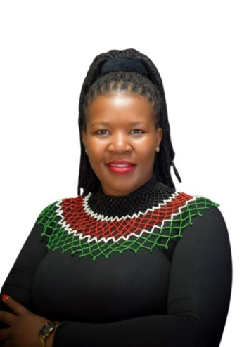
Gloria Hope Mwanyuma is serving in the Board of Directors Kenya Keys in charge of Fundraising and Resource mobilization.
Ms. Hope holds a Bachelors Degree in Environmental Studies and Community Development from Kenyatta University. Professionally, she holds a Certificate in Fundraising and Resource Mobilization from Pan African Christian University, Negotiation and Influencing from Chartered Institute of Fundraising and Strategic Resource Mobilization from Kenya Association of Fundraising Professionals. She is a registered Member of Kenya Association of Fundraising Professionals.
She is currently working with Living Goods as a Fundraising and resource mobilization Associate in identifying and securing new funding and partnership opportunities with organizations dedicated to healthcare, community development, and poverty alleviation, and expanding resource capacity for program initiatives. Concurrently, she is consulting with Kenya Keys as a resource mobilization expert (consultant). She led the first ever Kenya Keys grant and acquisition after submitting a very competitive grant proposals to both local and international donors.
Previously she worked with United Peace Organization as Fundraising, partnership and Grants Officer, Amnesty International as Project Campaign Officer: Human Rights Education, also worked with Commonwealth Youth Council as program Coordinator at Africa & Europe Special interest Group Standing Committee.
She brings to the Kenya Keys Board: Wealth of experience in resource mobilization initiative, donor relationship management and mentorship of young generations.

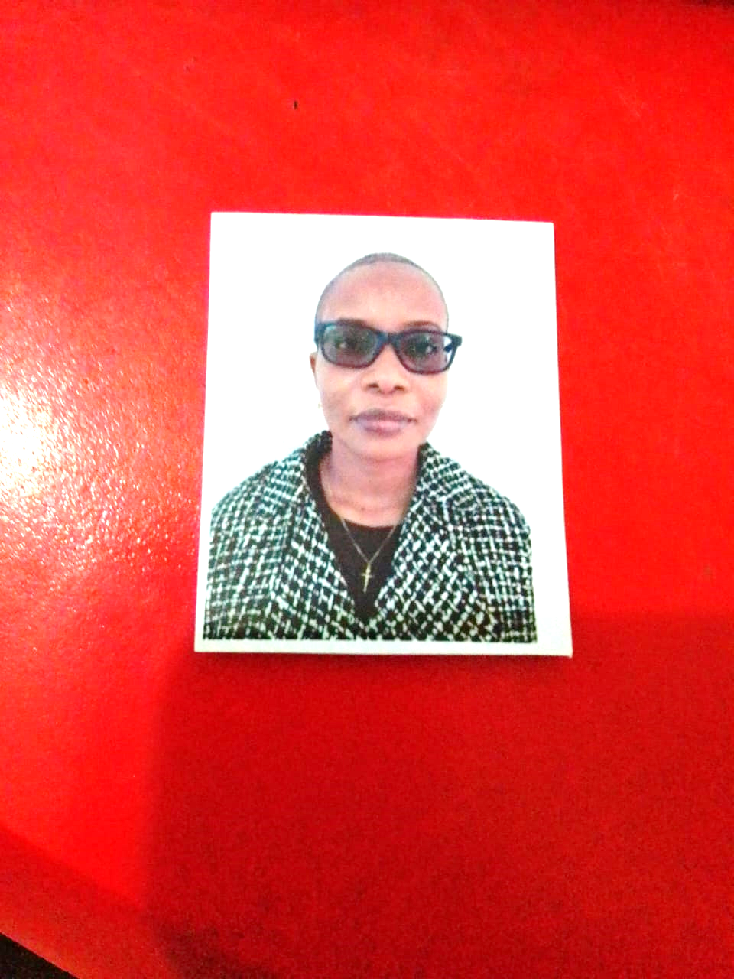
Alice Mwaka Ngome
Alice Mwaka Ngome is serving in the Board of Directors Kenya Keys in charge of Financial Oversight docket.
Alice Mwaka Ngome is a distinguished scholar in Computer Science in Web design, Database Management and Statistical Analysis (SPSS) and Chartered Certified Accountants (ACCA).
She also holds a Bachelor of Science in Computer Science. She holds other professional Training: Including courses in Database Management (MySQL, SQL, Oracle), Programming (Java, Visual Basic, C++), Web Design (PHP, XML, HTML), Statistical Analysis (SPSS), and various Microsoft Office skills.
She is a holder of Association of Chartered Certified Accountants (ACCA) for which she has completed 2 Levels (2003-2007).
In addition, she is the founder of a Research and Telecom Technology company where she is currently a Research Assistant and Telecom Technology Instructor.
Her previous private service includes working as a Senior Data Analyst at Alfa Solutions Ltd (2013-2019) in designing and maintaining data systems and databases; interpreted data using statistical tools, generating reports for executive leadership.
Prior to that she worked as a Fraud & Revenue Assurance Analyst at Safaricom Ltd (2010-2013). She managed payment transactions and promoted products to achieve revenue targets while ensuring high customer satisfaction. Earlier she worked as IT Officer - Alfa-Solutions Ltd. (2006-2008), where she managed LAN and WLAN networks, database systems, and troubleshooting tasks and customized software and provided technical support to end-users.
She brings to the Kenya Keys Board: a strong interpersonal and communication skills, Proficient in analytical, writing, presentation, and reporting and excellent organizational and leadership skills. Also brings on board strategic orientation, focused working schedules and highly skilled computerized systems.

Marstela Tesha
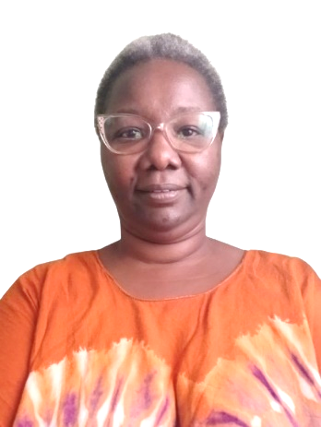
Mrs. Marstela Tesha is a member of the Board of Directors Kenya Keys, serving in the sub-committee of Award of Scholarship, Community Outreach and Infrastructure docket.
She holds a Certificate in teacher education (PTE) from Thogoto Teachers Training College.
Mrs Tesha is a dedicated and passionate Teacher with thirty three years of experience in Education. She is currently Deputy Headteacher at Kaphingo Primary School in Samburu sub county, Kwale county. Previously she has served as a Deputy Headteacher at Fuleye Primary School, Project officer at Agha Khan Foundation (AKF), Teacher at Mariakani Primary School and Teacher at Maji ya Chumvi Primary School.
A self-driven and enthusiastic educator and youth mentor. She has skills in Competence based Education System, fostering a supportive learning environment, and promoting academic excellence. She inspires students to reach their full potential and make a positive impact in their communities.
She will bring to Kenya Keys excellent communication skills, interpersonal skills, mentorship skills and a sense of positive attitude in community transformation efforts.


Raphael Mangisi
Mr. Raphael Mangisi is serving in the Board of Directors Kenya Keys Scholarships Committee.
He holds a Bachelors in Education in Early Childhood Education from Kenya Methodist University (KEMU). He also holds a Diploma in Early Childhood Development Education from Mombasa Dicece and a Certificate in Teacher Education (PTE) from Murang’a Teachers Training Centre.
He is a Professional devoted Teacher with twenty years of service in the Ministry of Education, Science and Technology employed by Teachers Service Commision.
He is currently a Deputy Headteacher at Kilibasi Primary School. Prior to his current appointment he served as a Senior Teacher Egu Primary School which was a rise of rank from a Classroom Teacher in the same institution.
He brings to the Kenya Keys Board: Strong expertise in curriculum delivery, student mentorship and collaborative community linkages. Also student guidance and conseling as he pursues academic watch initiatives to encourage poor performing students to aim higher and reach high levels of academic excellence.

Luvuno Lung’anzi Chai

Luvuno Lung’anzi Chai is serving in the Board of Directors Kenya Keys in charge of Advocacy and Compliance Docket.
Ms. Chai holds a Bachelor of Laws (LLB) and a Master of Laws (LL.M) in Commercial Law, both from Kampala International University. She also holds a Postgraduate Diploma in Law from the Kenya School of Law, and is currently pursuing a Postgraduate Diploma in Taxation at the Kenya School of Revenue Administration.
She currently serves as the Principal Legal Officer at the Speaker’s Office – Senate, where she advises on constitutional, legislative, and institutional matters at the national level. Her previous public service includes working as a Legal Officer at the State Department for Gender, where she supported national policy formulation, compliance, and response to gender-based violence. She has also worked in top private law firms including Muriu Mungai & Co. Advocates and Bailey & Co. Advocates.
In addition, she is the founder and managing partner of Luvuno Lunga’nzi & Co. Advocates, a legal practice based in Diani, Kwale County, providing a wide range of legal services in commercial transactions, conveyancing, succession, civil litigation, and legal advisory to businesses and civil society.
Beyond formal practice, Ms. Chai is deeply committed to grassroots empowerment. She volunteers as a Legal Officer with Samba Sport Organization in Kwale County, supporting children and youth through rights awareness, compliance, and child protection work. She has also served as a project lead with Matumbi Community-Based Organization, leading youth and women empowerment programs in semi-arid regions.
She brings to the Kenya Keys Board: Strong legal grounding in commercial law, governance, and legislative policy, public sector legal advisory and national institutions. Also bring youth mentorship, community development, gender justice and non- profit legal compliance and civic education.
With her unique blend of legal proficiency, policy insight, and community service, Ms. Chai offers invaluable perspective and leadership in advancing the mission of Kenya Keys Organization.

Linah Mkamaghanga Mjomba
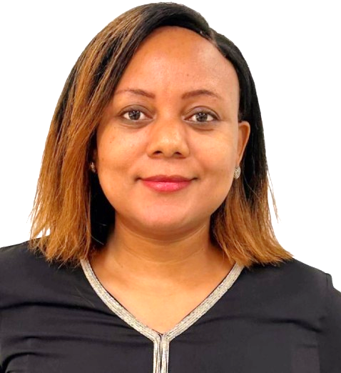
Linah Mkamaghanga Mjomba is serving as a Board of Director for Kenya Keys assisting in the docket of Planning and Development.
She is a Relation Manager, Wealth and Investment with over twelve years of experience of Banking System working at I&M Bank and Stanbic Bank.
Ms. Linah holds a Master of Science in Procurement and Logistics from Jomo Kenyatta University of Agriculture and Technology (JKUAT). She also holds a Bachelor of Business Management in Finance and Banking at Moi University. She holds other certifications as Certified Public Accounts Section I and II (KASNEB-2009), Certified in Corporate Credit Analysis at Institute of Business and Communications (India-2013-2014), Certified Wealth Practitioner (Moodys-August 2025), Chartered Institute for Securities & Investment Level I (CISI-April 2025) and Level II is ongoing.
In her career she has made academic publications in the following areas: Role of Procurement Management on Banks Financial Performance (A Case Study of I&M Bank) (www.semanticscholar.org.)
Publication: Effects Of Records Management on The Efficiency of The Procurement Function (A case study of Coast General Hospital) (www.semanticscholar.org)
She had seminars and training in other significant positions as: Training on KYC, Anti-Money Laundry, and Prudential Banking Guidelines, Capital Market Authority training on Investment Portfolios, 2009, Operations Officer at I & M Bank ltd, Personal Banker at Kenya Commercial Bank 2010-2011 and Financial Accounting Intern at Kenya Ports Authority, 2009.
Prior to her current position, she worked at I&M Bank LTD for twelve years as Customer Service Officer and rose the ranks of Relationship Manager, Premium Banking and Wealth & Investment Relationship Manager.
She brings to the Kenya Keys Board: Wealth and investment experience in organization investments, Linkages and partnership with corporate organizations to support the organization, Business management practices for profitability. Mentorship in guidance and counselling students.

